Charter Design

Prepared By: Asha

Document History
Version # | Date | Author | Revision Description
1.0 | 8/3/2024 | Asha Bhat | Initial draft

Contents
Document History 2
1. Overview 4
2. Development Environment 4
3. Technology Stack 5
4. RESTful endpoints 5
5. DB Entities: (Dataset) 5
6. API Endpoint 6
7. Architecture and Design 6

Overview

This document provides Design Details of a Retail application

A retailer offers a rewards program to its customers, awarding points based on each recorded purchase.
A customer receives 2 points for every dollar spent over $100 in each transaction, plus 1 point for every dollar spent between $50 and $100 in each transaction.
(e.g. a $120 purchase = 2x$20 + 1x$50 = 90 points).
Given a record of every transaction during a three month period, calculate the reward points earned for each customer per month and total.

Development Environment

IDE
IntelliJ is the recommended IDE. This was chosen because it’s extremely flexible, easily extensible, and covers everything we need for developing applications.

Postman
This tool is used for internal Unit Testing of the REST API for developers

Git
Git is used as Code Repository to check-in the code

MySQL / Postgres DB
This DB is used to store Customer Details
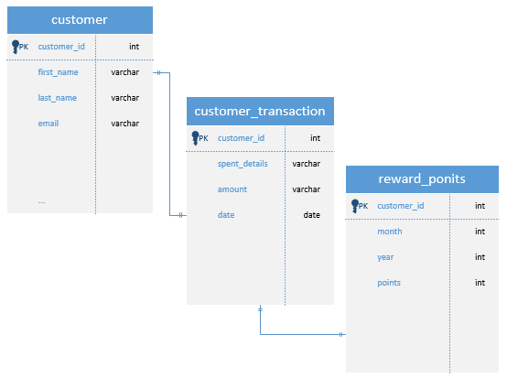

Technology Stack
Application Framework | Spring Boot, Rest API, Java 22
Build tool | Maven
Code repository | Local
IDE | IntelliJ IDEA

RESTful endpoints
Customer APIs:
- /customer/registration
- /customer/login
- /customer /loggoff
(Assumption customer data is already available: customer sample data to populate in DB to support REST APIs)

Customer Transaction:
- /customer/getCustomer
- /customer/addCustomer
- /customer/editCustomer
- /customer/deleteCustomer

DB Entities: (Dataset)
Entities
- Customer
  - id: Long (PK)
  - name: String
- Transaction
  - id: Long (PK)
  - customerId: Long (FK)
  - amount: Double
  - date: LocalDate
- RewardPoints
  - customerId: Long (FK)
  - month: YearMonth
  - points: Integer

API Endpoint:
/rewards/{id}
The following guidelines pertain to general coding standards.

Architecture and Design
Layers
- Presentation Layer: RESTful APIs for interacting with the application.
- Service Layer: Business logic for calculating reward points.
- Data Access Layer: Interactions with the database to store and retrieve transaction data.
Components
- Controller: Handles HTTP requests and responses.
- Service: Contains business logic for calculating reward points.
- Repository: Interfaces with the database.
Exception handling
- Standard using try-catch
Error logging
- Log4j

